Electronic Supplementary Material for: Convergent evolution in toothed whale cochleae

Specimen List
Table S1. Specimens used in this study. Institutional abbreviations: AMNH, American Museum of Natural History, New York, USA; IRNSBV, Belgian Royal Institute of Natural Sciences, Brussels, Belgium; NMB, Naturhistorisches Museum Basel, Basel, Switzerland; NHMUK, Natural History Museum, London, England; NMVC, Museums Victoria, Melbourne, Australia.
Taxon | Specimen number | Resolution (μm)
Cephalorhynchus commersonii | NHMUK1952.6.20.4 | 32.08
Cephalorhynchus heavisidii | NHMUK1948.7.27.1 | 32.08
Delphinus delphis | NMB6679 | 40
Feresa attenuata | NHMUK1874.11.25.1 | 47.52
Globicephala melas | NHMUK1947.12.31.4 | 32.11
Grampus griseus | NHMUK1920.12.16.1 | 25.72
Lagenodelphis hosei | NHMUK1895.5.9.1 | 38.75
Lagenorhynchus acutus | NHMUK1928.19 | 32.27
Lagenorhynchus albirostris | NHMUK1848.7.12.12 | 32.08
Lagenorhynchus australis | NHMUK1944.11.30.1 | 32.27
Lagenorhynchus cruciger | NHMUK1960.8.24.1 | 32.27
Lagenorhynchus obliquidens | NHMUK1966.10.25.1 | 39.75
Lagenorhynchus obscurus | NHMUK1841.1733 | 39.75
Orcaella brevirostris | NHMUK1883.11.20.2 | 32.11
Orcinus orca | NHMUK1927.28 | 39.84
Peponocephala electra | NHMUK1992.100 | 32.08
Pseudorca crassidens | NHMUK1992.248 | 39.84
Sotalia fluviatilis | NHMUK1856.8.2.2 | 43.75
Sotalia guianensis | IRSNBV20137 | 30.47
Sousa chinensis | NHMUK1914.1.14.1 | 32.27
Stenella attenuata | NHMUK1990.98 | 37.66
Stenella coeruleoalba | NHMUK1940.3.2.1 | 37.66
Stenella longirostris | NHMUK1990.104 | 32.27
Steno bredanensis | NMVC36961 | 32.97
Tursiops aduncus | NHMUK1882.1.2.3 | 39.75
Tursiops truncatus | NHMUK1866.8.7.1 | 32.27
Inia geoffrensis | NMB7167 | 30
Kogia breviceps | NMVC24976 | 33.07
Kogia sima | NHMUK1952.8.28.1 | 32.27
Lipotes vexillifer | AMNH57333 | 30.7
Delphinapterus leucas | NMBCIII1086 | 40
Monodon monoceros | AMNH73315 | 40.69
Neophocaena phocaenoides | NHMUK1903.9.12.3 | 32.27
Phocoena dioptrica | NHMUK1939.9.30.1 | 38.75
Phocoena phocoena | NMVC27654 | 33.08
Phocoena spinipinnis | IRSNBV21219 | 27.35
Phocoenoides dalli | NHMUK1965.1.19.2 | 43.75
Physeter macrocephalus | NHMUK893 | 42.14
Platanista gangetica | NMVC27417.2 | 41.5
Pontoporia blainvillei | MNHN1934.375 | 38
Berardius arnuxii | NHMUK1982.315 | 49.67
Hyperoodon ampullatus | NHMUK1862.12.2.2 | 41.06
Mesoplodon bidens | IRSNB16232 | 35
Mesoplodon grayi | NMVC31378 | 44.02
Mesoplodon hectori | NHMUK1876.2.16.3 | 30.11
Mesoplodon mirus | NHMUK1920.5.20.1 | 47.52
Tasmacetus shepherdi | NMVC37967.6 | 58.28
Ziphius cavirostris | NHMUK1915.7.20.1 | 33.57

Landmark/curve Definitions
Fenestra vestibuli
Curves 0 – 3: 4 curves (1 per quarter): starts at midline of vestibular curve, travels anticlockwise (in vestibular view), at level of the point where the lateral semi-circular canal meets the fenestra vestibuli, finishes on same point
Cochlear canal
Curves 4 – 11: 8 curves on medial-most outline of scala vestibuli: starts where vestibular curve meets cochlear canal, finishes on apex
Curves 12 – 19: 8 curves on ventral-most outline of scala vestibuli: starts where vestibular curve meets cochlear canal, finishes on apex
Curves 20 – 30: 11 curves lateral most outline of scala vestibuli (starting at dorsal-most point of scala vestibuli), finishes on apex
Curves 31 – 39: 9 curves dorsal-most outline of scala tympani (starting just anterior to where cochlear aqueduct joins cochlear canal), finishes on apex
Vestibular aqueduct
Curve 40: 1 curve along its length ending at endolymphatic sac: runs along anterior surface
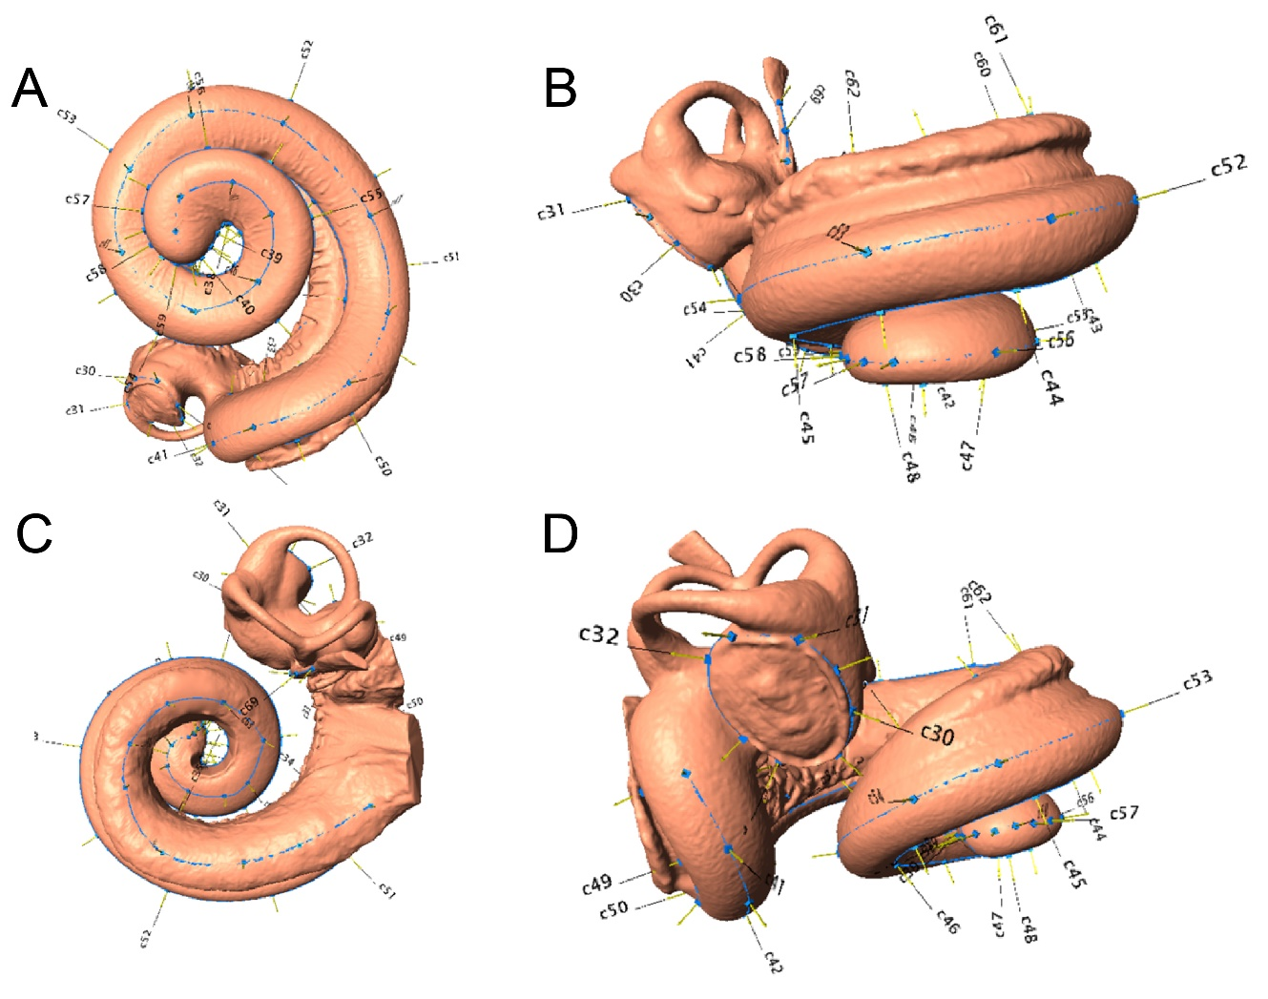

Figure S1. Cochlea of Cephalorhynchus commersoniii (NHMUK1952.6.20.4.2) in: (A) vestibular; (B) anterior; (C) dorsal; and (D) lateral views, showing placement of landmarks for this study.
Chi-squared analyses results
Table S2. Results of χ² analysis. Χ²: chi-squared value; df: degrees of freedom; bc: Bonferroni corrected p-value. Habitat1: all “riverine/nearshore” taxa are classed as “riverine” and “nearshore/oceanic” taxa are classed as “nearshore”; Habitat2: all “riverine/nearshore” taxa are classed as “nearshore” and “nearshore/oceanic” taxa are classed as “oceanic”; Feeding1: all “raptorial/suction” taxa are classed as “raptorial”; Feeding2: all “raptorial/suction” taxa are classed as “suction”. Significant ecological categories in bold.
 | Regime A |  |  |  | Regime B |  |  |  | Regime C
 | x² | df | p-value | bc p-value | x² | df | p-value | bc p-value | x² | df | p-value | bc p-value
Diet | 3.224 | 2 | 0.200 | 1 | 6.860 | 2 | 0.032 | 0.583 | 4.466 | 2 | 0.107 | 1
Habitat 1 | 16.39 | 2 | 0.000 | 0.005 | 4.174 | 2 | 0.124 | 1 | 1.699 | 2 | 0.428 | 1
Habitat 2 | 3.725 | 2 | 0.155 | 1 | 0.949 | 2 | 0.622 | 1 | 1.455 | 2 | 0.483 | 1
Feeding 1 | 6.350 | 1 | 0.012 | 0.211 | 0.568 | 1 | 0.451 | 1 | 1.517 | 1 | 0.218 | 1
Feeding 2 | 5.749 | 1 | 0.017 | 0.297 | 0.479 | 1 | 0.489 | 1 | 1.335 | 1 | 0.248 | 1
Dive type | 8.908 | 2 | <0.001 | <0.001 | 2.268 | 2 | 0.028 | 0.517 | 3.478 | 2 | 0.051 | 0.918

3 PC & 4 PC Analyses Results
SURFACE analyses
Table S3. Results of the SURFACE analysis using 3 PCs. Parameters were found by the evolutionary models fitted to the evolution of cochlear shape in toothed whales described by PC1, PC2 and PC3. Abbreviations: α, rate of adaptation to optima; t_{1/2},; σ², rate of stochastic evolution; θ, optimum trait value for each regime.
Parameter | Value
AICc | -547.6001
Phenotypic regimes | 6
Pheno reg shifts | 9
Conv pheno reg | 3
Conv reg shifts | 6
Conv fraction | 0.66
 | PC1 | PC2 | PC3
α | 0.3055731 | 3.5860466 | 0.2034437
t_{1/2} | 2.2683512 | 0.1932901 | 3.4070705
σ² | 0.000394199 | 0.00459924 | 0.000389555
θ_{a} | 0.06475327 | 0.05540134 | 0.054914713
θ_{b} | 0.05525293 | -0.0979297 | 0.424337912
θ_{c} | 0.10949494 | 0.17117225 | 0.105221289
θ_{d} | -0.12552789 | -0.0105983 | 0.016383934
θ_{f} | 0.01960091 | -0.0127686 | -0.01536403
θ_{g} | -0.07812261 | 0.13443546 | -0.00662119

Table S4. Results of the SURFACE analysis using 4 PCs. Parameters were found by the evolutionary models fitted to the evolution of cochlear shape in toothed whales described by PC1, PC2, PC3 and PC4. Abbreviations: α, rate of adaptation to optima; t_{1/2}, expected time to evolve halfway to an optimum; σ², rate of stochastic evolution; θ, optimum trait value for each regime.
Parameter | Value
AICc | -723.6117
Phenotypic regimes | 7
Pheno reg shifts | 9
Conv pheno reg | 2
Conv reg shifts | 4
Conv fraction | 0.44
 | PC1 | PC2 | PC3 | PC4
α | 0.2126589 | 0.2834478 | 0.1456725 | 0.1111551
t_{1/2} | 3.259431 | 2.445414 | 4.758257 | 6.235857
σ² | 0.00028452 | 0.00045942 | 0.00030189 | 0.000159964
θ_{a} | -0.12532507 | -0.01065699 | 0.016172771 | -0.017275535
θ_{b} | 0.06922345 | -0.17092699 | 0.556174253 | 0.630543914
θ_{c} | 0.12299196 | 0.24896805 | 0.113935723 | -0.047773283
θ_{d} | -0.07552558 | 0.14403766 | -0.008966596 | 0.069964052
θ_{e} | 0.0868295 | -0.06262475 | -0.077356961 | -0.364601342
θ_{g} | 0.06390308 | 0.0377028 | 0.054711786 | -0.045510447
θ_{h} | 0.01874895 | -0.01094644 | -0.015387493 | 0.002121349

C-metric analyses
Table S5. C₁ - C₄ convergence measures and p-values using 3 PCs. P-values were derived from 1000 simulations to test the hypothesis that the observed values are greater than random simulations based on Brownian motion. Significant values in bold.
Regime A | C1 | C2 | C3 | C4
C-value | 0.68877399 | 0.12592615 | 0.39373833 | 0.02373326
P-value | 0 | 0 | 0 | 0
Regime B | C1 | C2 | C3 | C4
C-value | 0.849605 | 0.2225559 | 0.5308192 | 0.4826925
P-value | 0 | 0 | 0 | 0
Regime C | C1 | C2 | C3 | C4
C-value | 0.256274777 | 0.031864892 | 0.056861626 | 0.006005566
P-value | 0.07792208 | 0.04195804 | 0.31368631 | 0.30669331
Table S6. C₁ - C₄ convergence measures and p-values using 4 PCs. P-values were derived from 1000 simulations to test the hypothesis that the observed values are greater than random simulations based on Brownian motion. Significant values in bold.
Regime D | C1 | C2 | C3 | C4
C-value | N/A | N/A | N/A | N/A
P-value | N/A | N/A | N/A | N/A
Regime E | C1 | C2 | C3 | C4
C-value | 0.7049156 | 0.2275502 | 0.4730401 | 0.4382331
P-value | 0.000999001 | 0.000000000 | 0.000000000 | 0.000000000

Wheatsheaf analyses
Table S7. Results of the Wheatsheaf index analysis using 3 PCs. WI: Wheatsheaf index.
Conv reg | WI value | P-value | 95% CI
Regime A | 1.022464 | 0.747 | 0.9526044 - 1.089544
Regime B | 2.194074 | 0.34 | 2.092535 - ∞
Regime C | 1.472754 | 0.679 | 1.404596 - 2.749955

Table S8. Results of the Wheatsheaf index analysis using 4 PCs. WI: Wheatsheaf index.
Conv reg | WI value | P-value | 95% CI
Regime D | 2.420819 | 0.292 | 2.324896 - ∞
Regime E | 0.951743 | 0.14 | 0.9319229 - 0.9725553

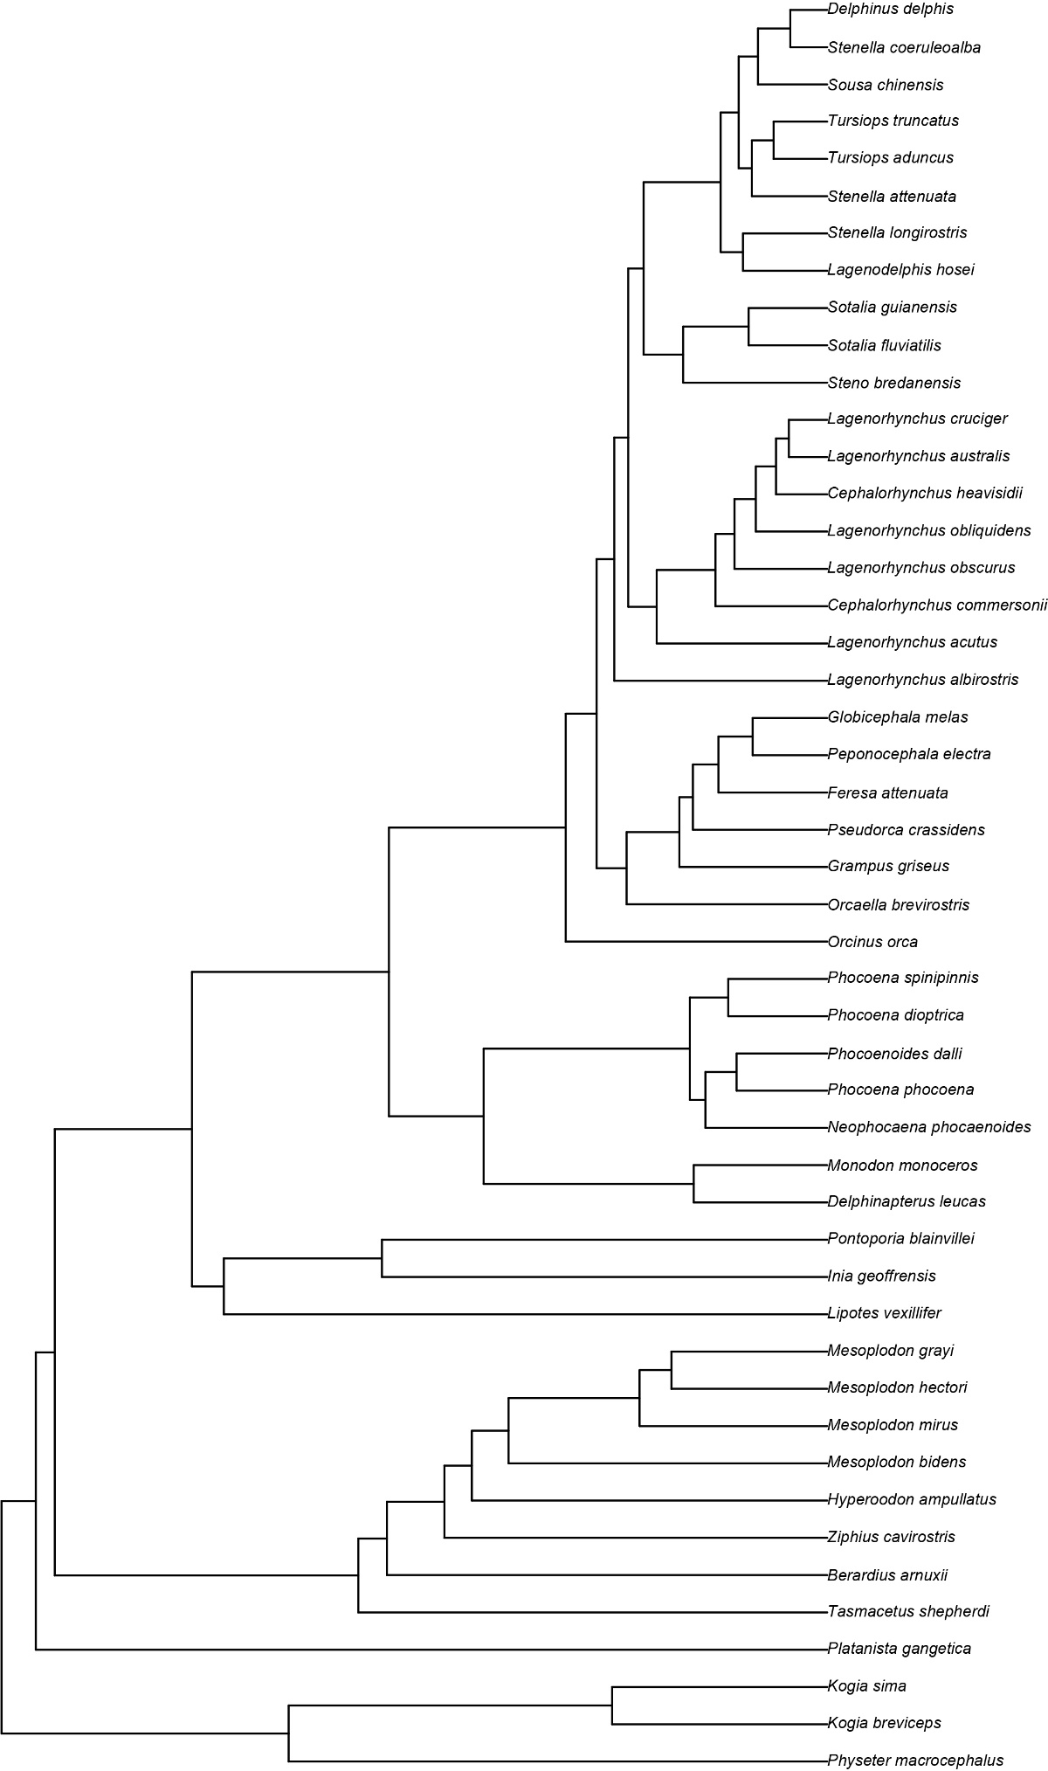
Figure S2. Cladogram showing the phylogenetic relationships of the taxa in this study.

